The announcement concerning 2023/2024 winter session organization

We kindly remind that all students should pass their subjects and/or obtain their grades in the period between January, 22nd and January, 26th 2024 (before the exam session).

The exam session will be held between January, 27th and February, 2nd 2024.

The student’s semestral achievement form will be available in electronic version only (at eHMS).

Winter semester ending — schedule:

- The classes continue until January, 26th (included).
- Jan, 22nd — Jan, 26th — passing subjects and obtaining grades
- Jan, 27th — Feb, 2nd — exam session
- Feb, 12th — Feb, 17th — winter make-up exam session
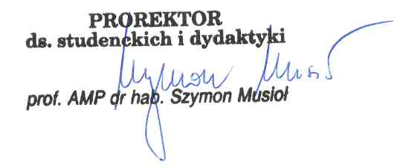
- Feb, 5th — Feb, 11th — winter break

Poznań, January, 17th 2024.

